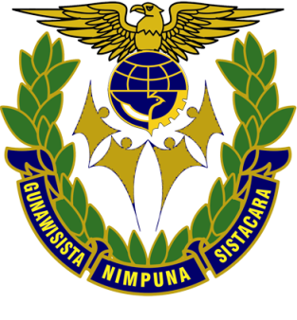

AIRCRAFT ENGINEERING
MODULE for DIPLOMA III

TEKNOLOGI MEKANIK II

2013

MINISTRY OF TRANSPORTATIONS
HUMAN RESOURCES DEVELOPMENT AGENCY OF TRANSPORTATION
AIR TRANSPORTATION HUMAN RESOURCES DEVELOPMENT CENTER

