AIRCRAFT ENGINEERING
MODULE for DIPLOMA III

AIRCRAFT INSTRUMENT

TIM PENYUSUN

KETUA

SEKRETARIS

ANGGOTA

TIM AHLI

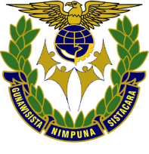

MINISTRY OF TRANSPORTATIONS
HUMAN RESOURCES DEVELOPMENT AGENCY OF TRANSPORTATION
AIR TRANSPORTATION HUMAN RESOURCES DEVELOPMENT CENTER

